ML Algorithms

Decision Tree:

A Decision Tree is a model that makes decisions step by step, the same way humans do

* Pseudo Code:

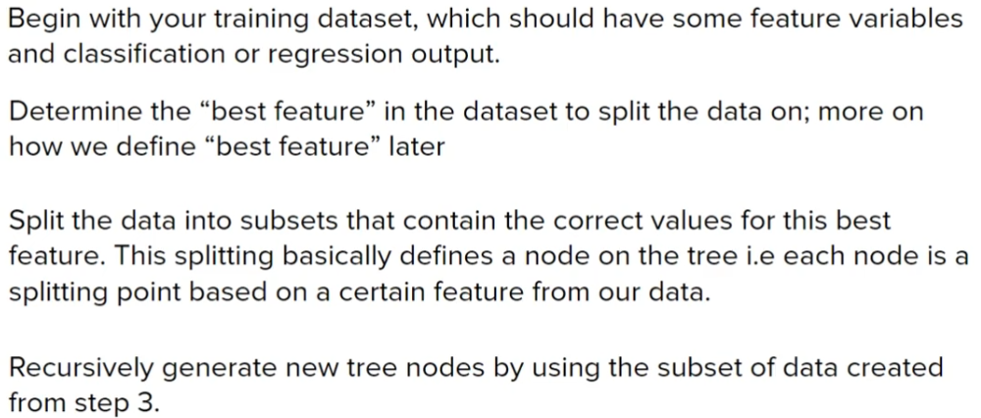

* Terminologies:

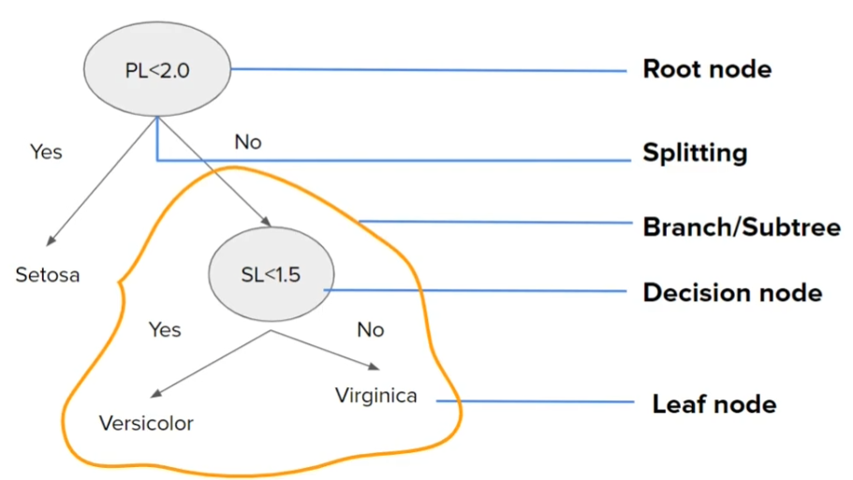

Advantages:

Intuitive easy to understand, minimal data preparation required

Disadvantages:

Overfitting, prone to errors in imbalanced datasets

This algo is mostly used for classification but can be used on regression in certain cases

Entropy: measures how mixed or uncertain a group is.

* Why decision trees care about entropy

Decision trees ask: “Which question reduces uncertainty the most?”

* Mathematical intuition:

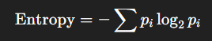

* Shape:

• Entropy is **highest** when classes are evenly mixed

• Entropy is **lowest** when one class dominates

• Entropy curve looks like an upside-down bowl

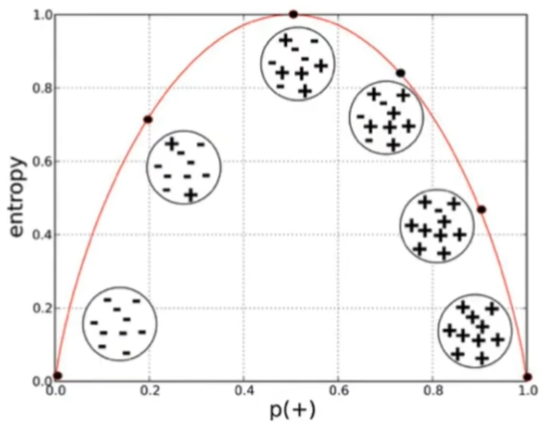

* Decision tree tries to minimize entropy but not directly:



It tries to reduce it step by step

* The Information Gain is based on decrease in entropy after data-set is split on an attribute
* Constructing a decision tree is all about finding attribute that return highest IG
* For more than two classes the entropy can max beyond 1
* Entropy for the continuous data:

The data with higher entropy is that, whichever is less peaked in the plot

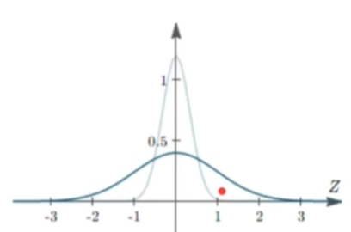

The dark blue line has high Entropy as compare to other one

Steps to perform decision tree:

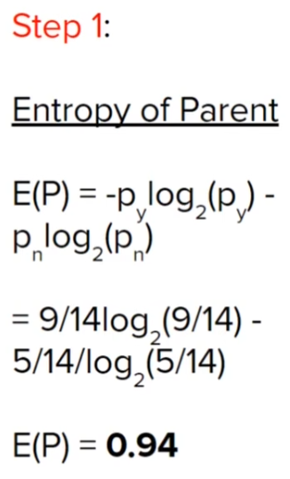

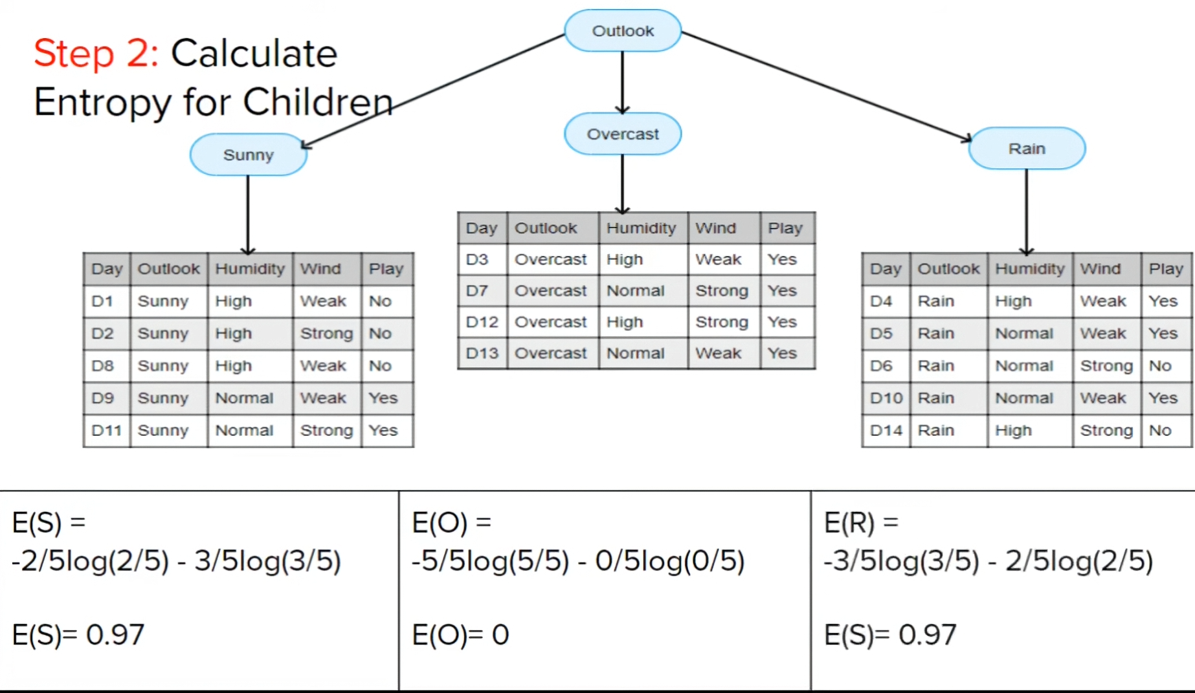

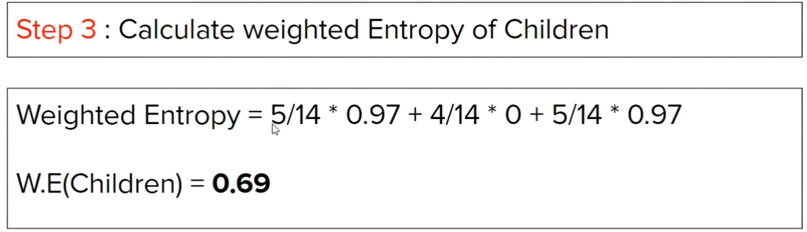

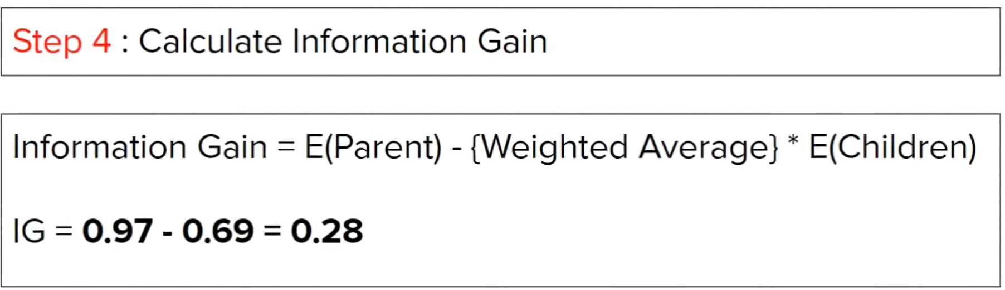

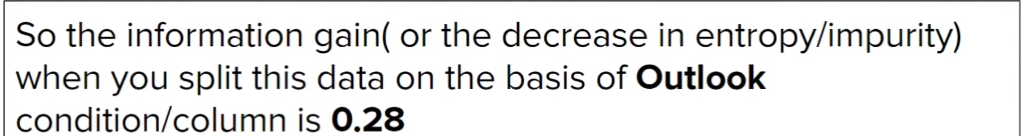



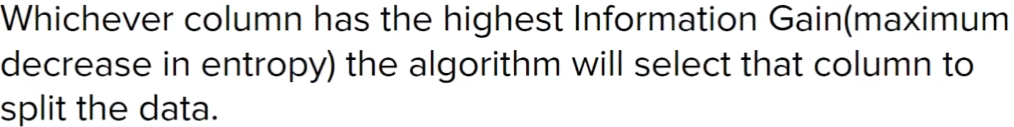

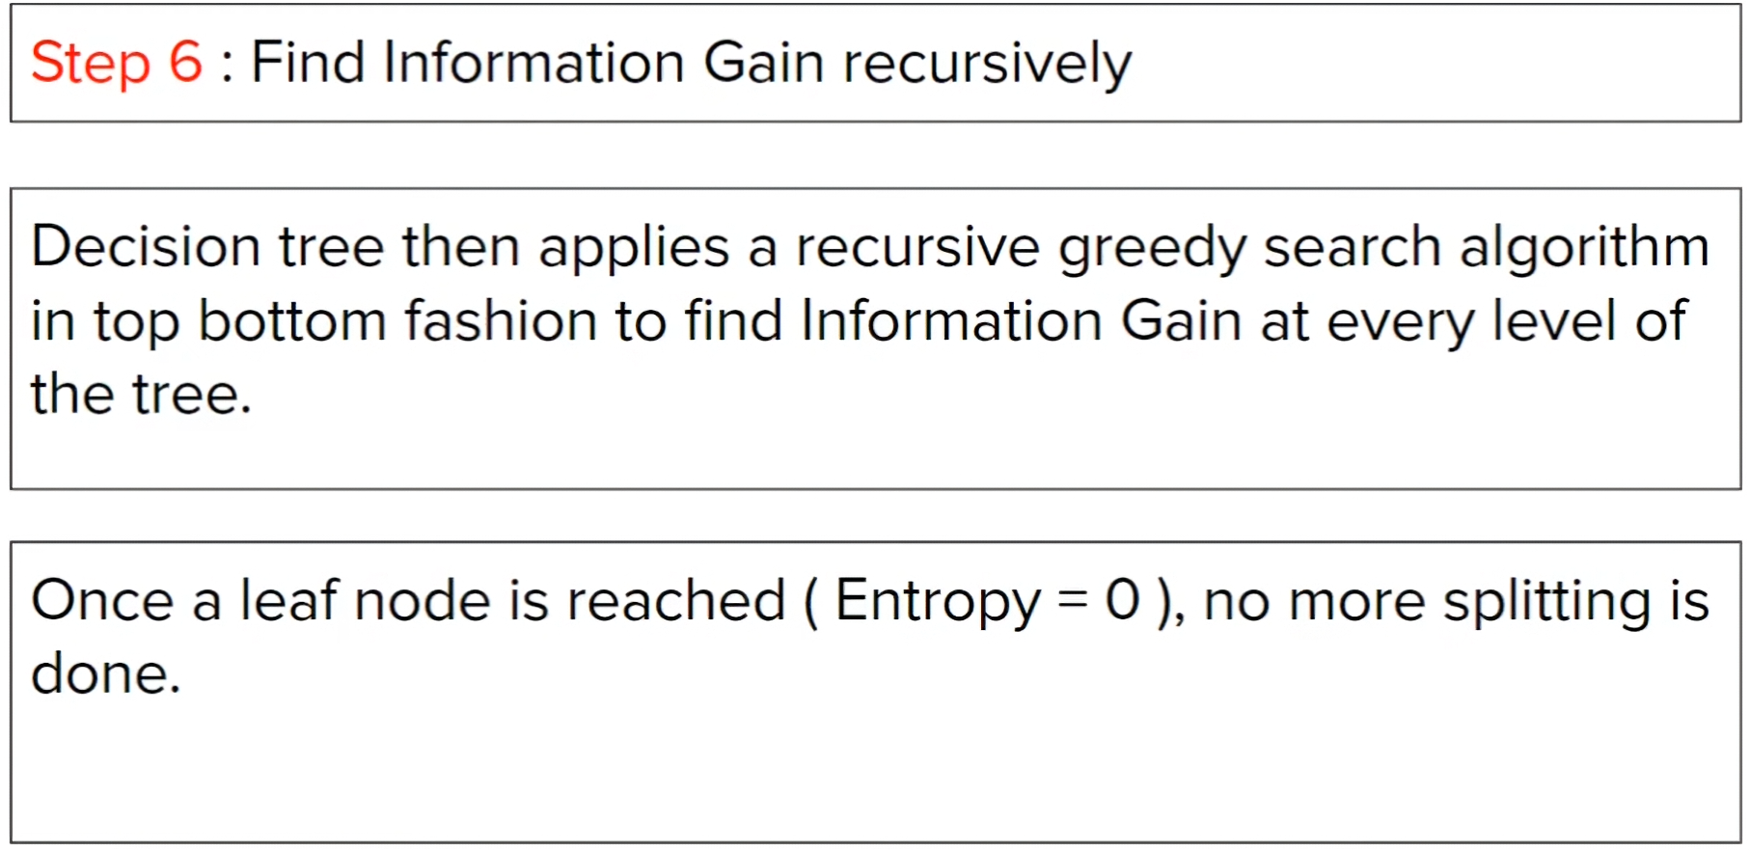

Gini Impurity:

Gini impurity measures how likely you are to make a wrong classification  
if you randomly label a point according to the class distribution in a node.

Explaining what is the use with example:

If I land on a node and its

- 70% Spam

- 30% Not Spam

I randomly pick an email and guess its label using same proportions than

There is chance I will guess wrong, that chance is Gini Impurity

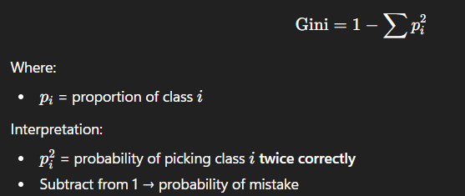

Decision tree ask which split reduce impurity most

So, they choose splits that:

* Lower Gini in children
* Make nodes purer quickly

Important:

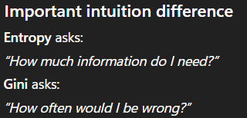

What does Split looks like in Continuous data:

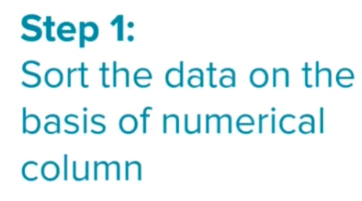

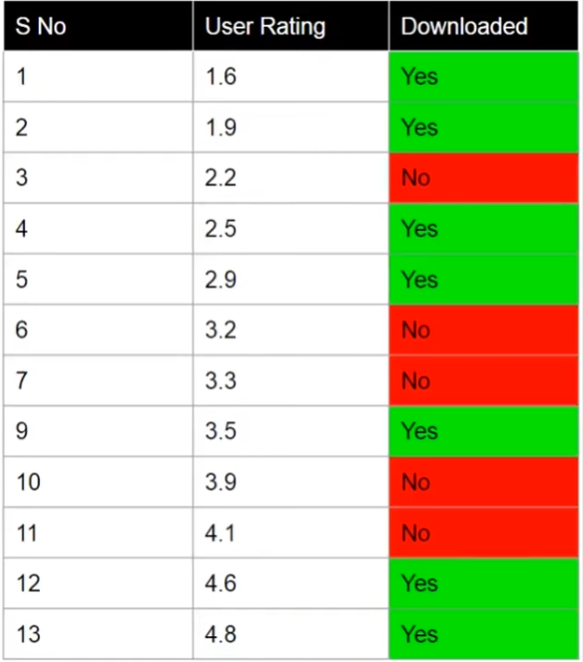

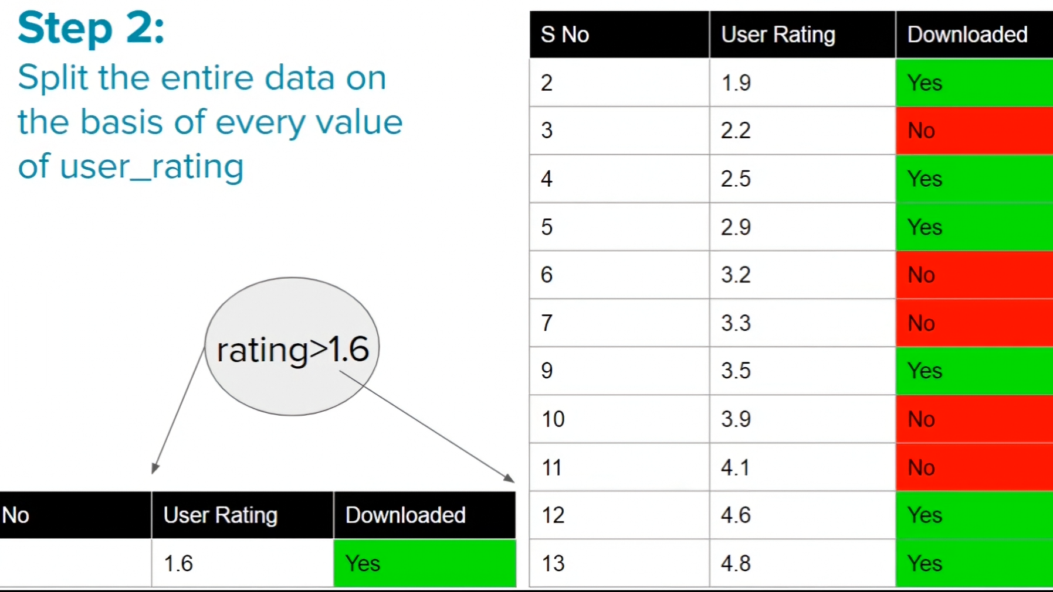

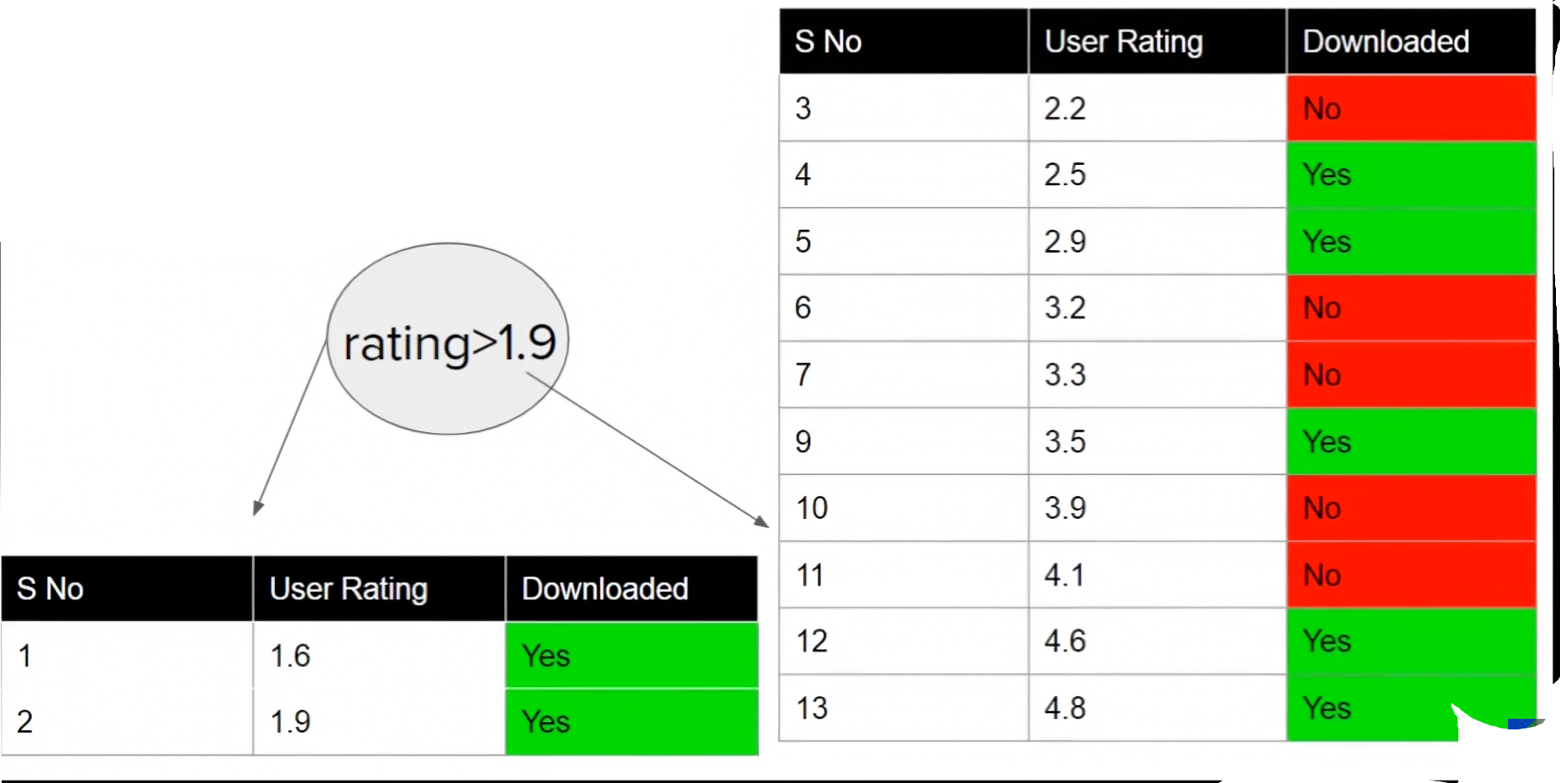



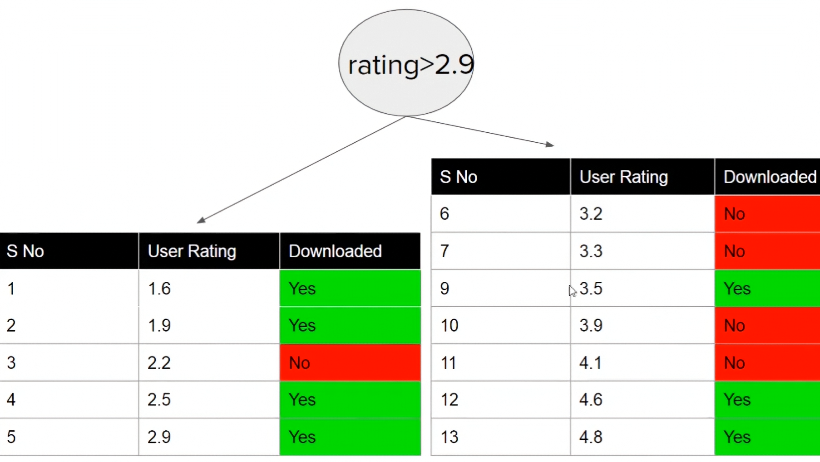

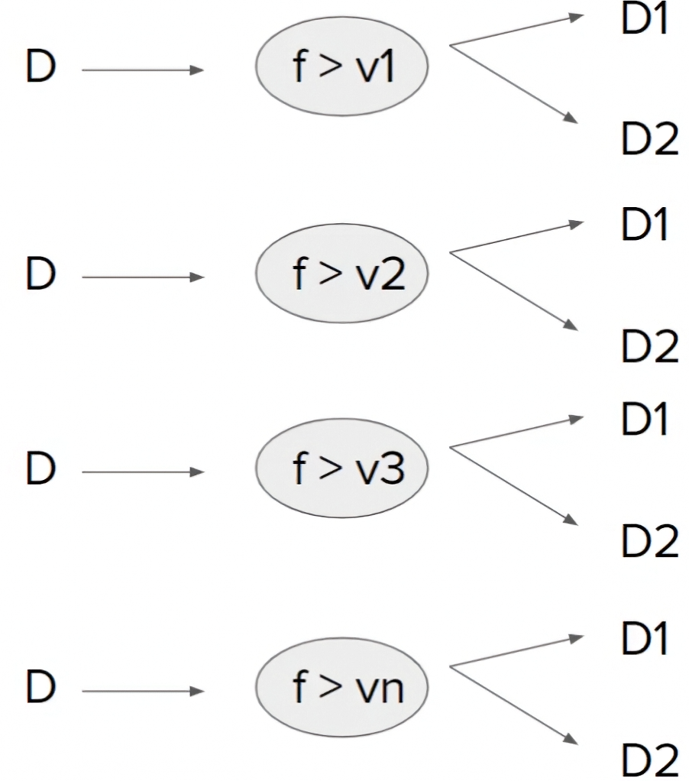

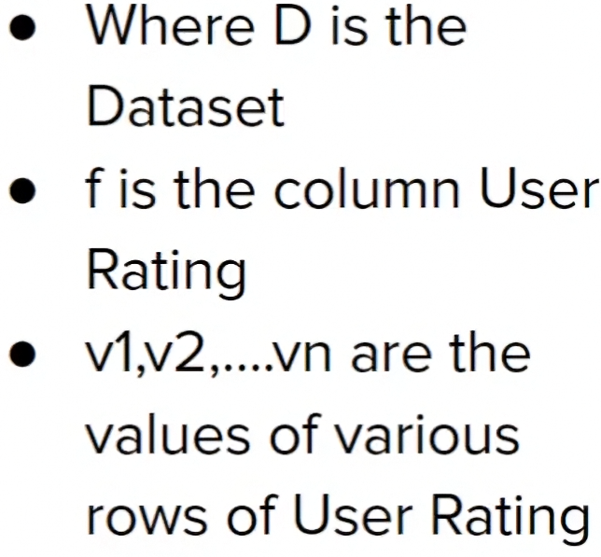

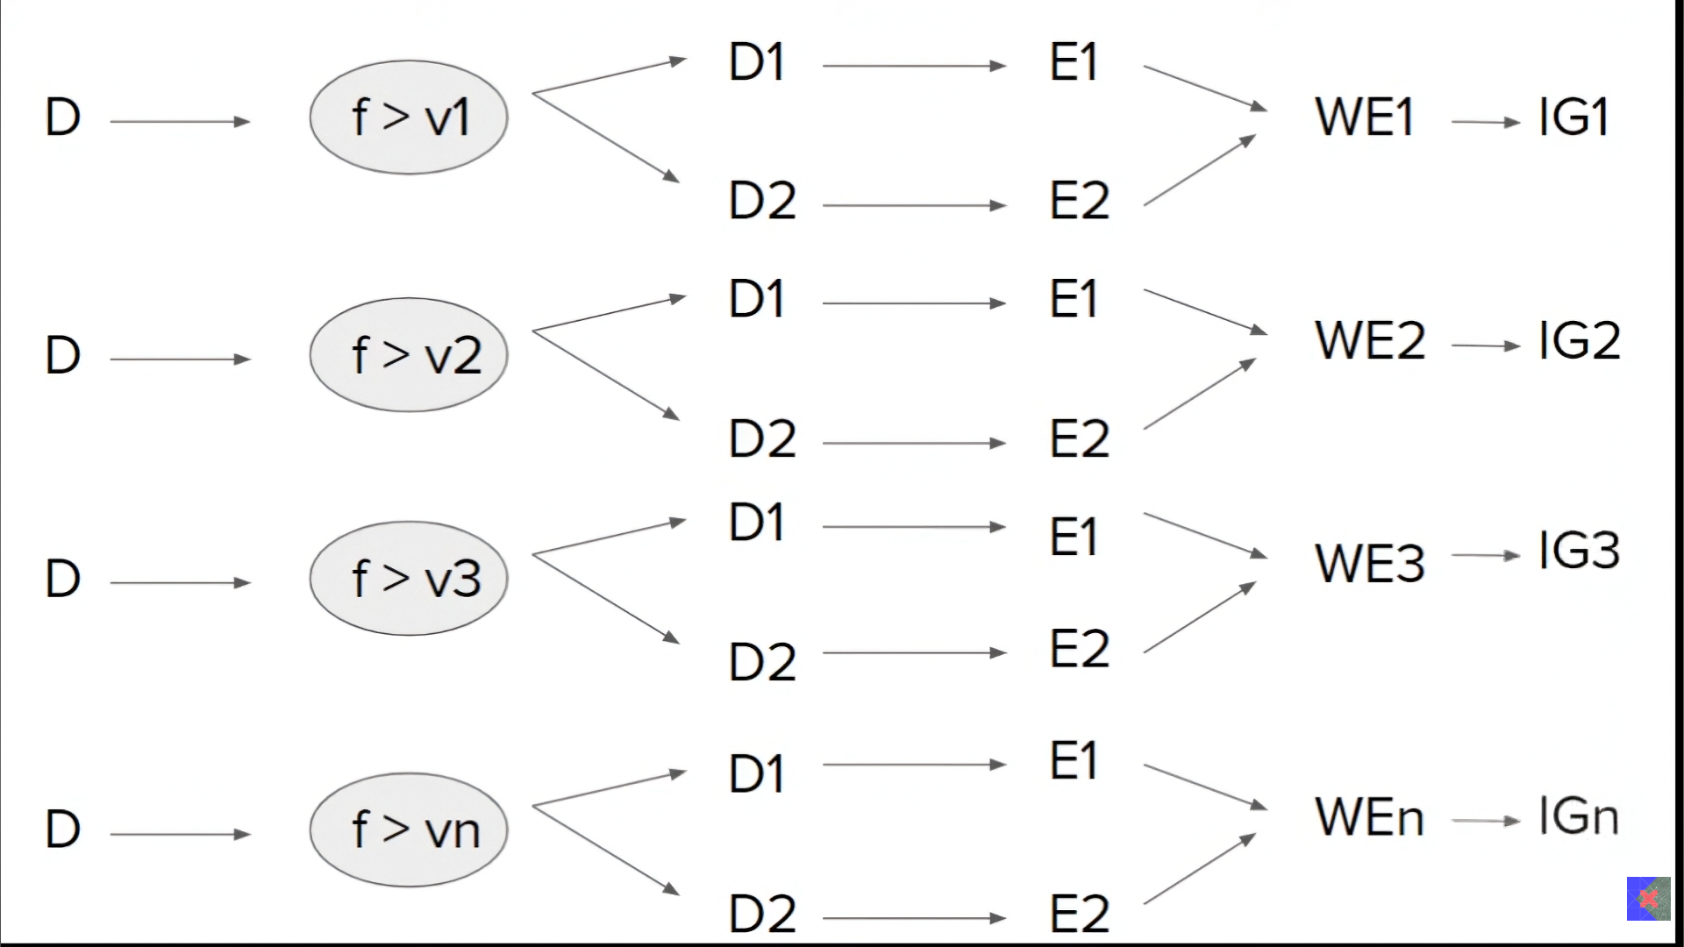



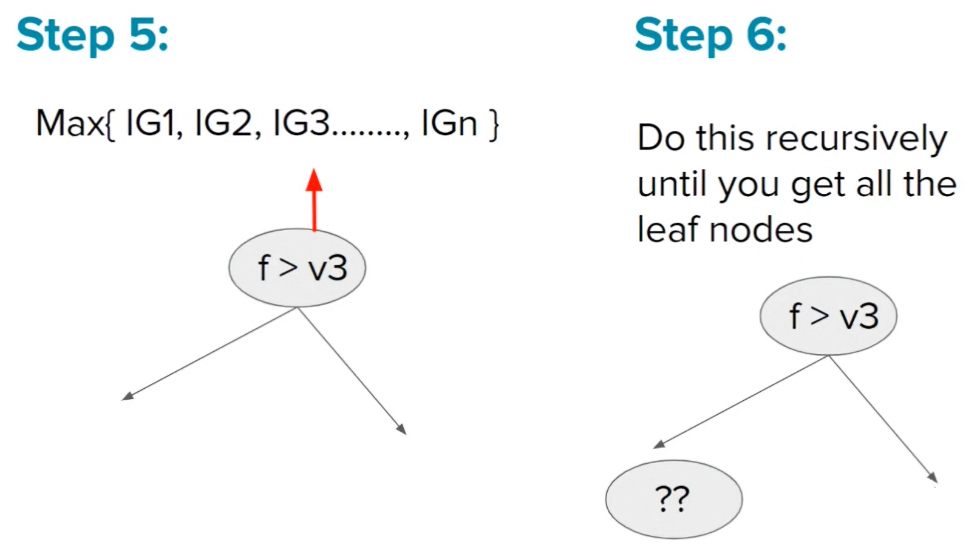

Regression Tree:

* Key Difference:

|  |  |  |
| --- | --- | --- |
| **Aspect** | **Classification Tree** | **Regression Tree** |
| Output | Class | Continuous value |
| Leaf value | Majority class | Mean value |
| Impurity | Gini / Entropy | Variance / MSE |

* Leaf node store: the avg (mean) of target values
* In regression trees impurity means how spread-out target values are

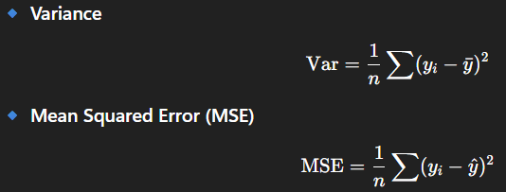

* How splitting works with example:

Sample dataset:

|  |  |
| --- | --- |
| **Size (sqft)** | **Price** |
| 500 | 100 |
| 600 | 120 |
| 700 | 130 |
| 900 | 200 |
| 1000 | 220 |

Step 1: sort by feature

**Step 2: Try split points (midpoints)**

Possible thresholds:

550

650

800

950

**Step 3: Try one split (example)**

Split at **Size ≤ 800**

* **Left:**

Prices: [100, 120, 130]

Mean = 116.7

Variance = small

* **Right:**

Prices: [200, 220]

Mean = 210

Variance = small

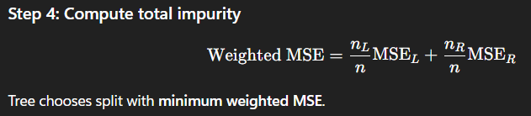

**Why regression trees overfit easily**

Because they:

Keep splitting

Reduce variance locally

Memorize noise

Deep trees:

Low training error

High test error

Classic **high-variance model**.

* We can control splitting using hyperparameters: max_depth, min_samples_leaf, min_samples_split